Parish Welcome for those Newly Confirmed, their Parents, Families and Sponsors at Weekend Mass

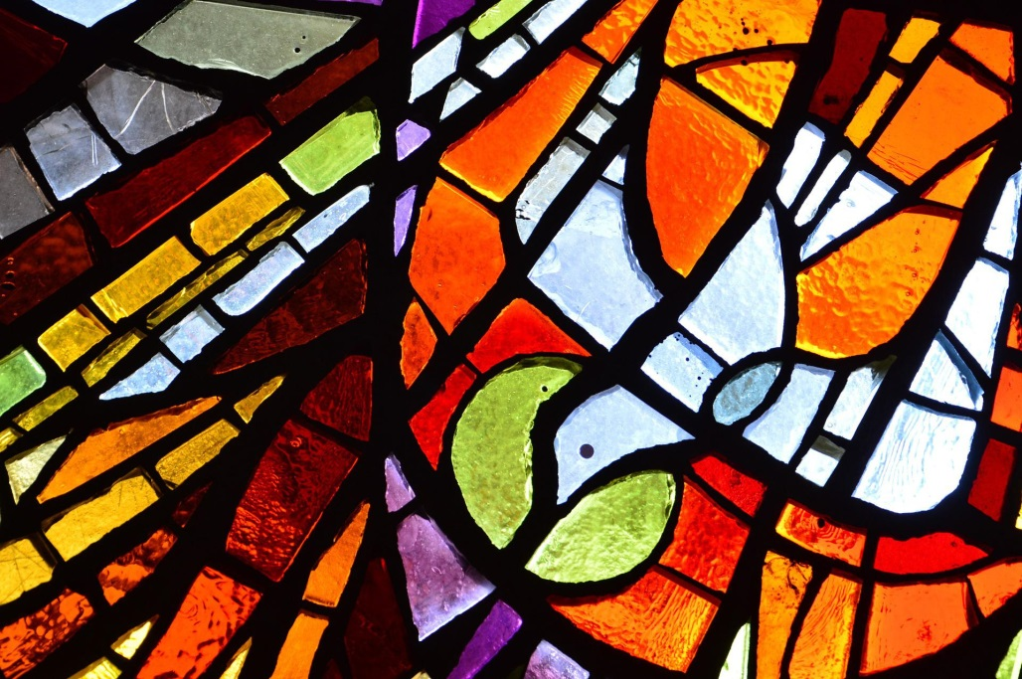

Diocese of Clonfert

During the Rite of Confirmation without Mass, the candidates, their parents, families and sponsors are invited to attend Mass in their local church on the following weekend – where they are to be especially welcomed.
The following might assist with arranging this.

- An individual personal invitation from the Priest or the Parish Pastoral Council might be issued to every newly confirmed, their parents, family and sponsor as appropriate.

- A notice about the welcome should be placed in the Parish Newsletter eg. At all Masses in our parish this weekend we will welcome in a special way those who received the Sacrament of Confirmation during the week, their parents, their family and sponsors.

- Artwork from the Confirmation Ceremony should remain in the Church for the weekend Masses – perhaps some appropriate decoration of other Churches in the parish might also take place.

- Those newly confirmed, their parents, family members and sponsors might be actively included in the liturgy as readers, gift bearers, musicians, members of the choir, etc.

- Those newly confirmed, their parents, family members and sponsors should be welcomed in the introduction to the Liturgy. Perhaps the congregation could be invited to give them a round of applause or some other appropriate acknowledgement of their presence. They and their families should be congratulated at the conclusion.

- The celebrant might use the occasion to preach about the Sacrament of Confirmation and the role of the Holy Spirit in the life of a Christian.

- A prayer of the faithful should be included for the newly confirmed:
We pray today for those who during the week celebrated the Sacrament of Confirmation in our parish – may the Holy Spirit be a powerful helper and guide for them on their journey of life. Lord Hear us

- At the end of Mass the sending out Prayer from the Confirmation might be included and led by one of the newly confirmed.

The Sending Out
Priest: Empowered by the Spirit, we now, like the Apostles on that First Pentecost Day, are sent out into our world to proclaim the Good News: God loves us and he has set our hearts on fire with love for him and for each other.

Newly Confirmed: Empowered by the Spirit, I go into the world
Empowered by the Spirit, I go to my neighbours
Empowered by the Spirit, I am sent to my friends
Empowered by the Spirit, I go to my school
Empowered by the Spirit, I am sent to my family
Empowered by the Spirit, we move out now
Continue together:

All: Filled with the Holy Spirit, we move out now. Out into our world to proclaim in word and deed the wonderful things God does for us. Amen.

- A cup of tea/coffee could be provided on this one day – or even a few boxes of sweets as people are leaving to emphasise the community celebration/ welcome.

