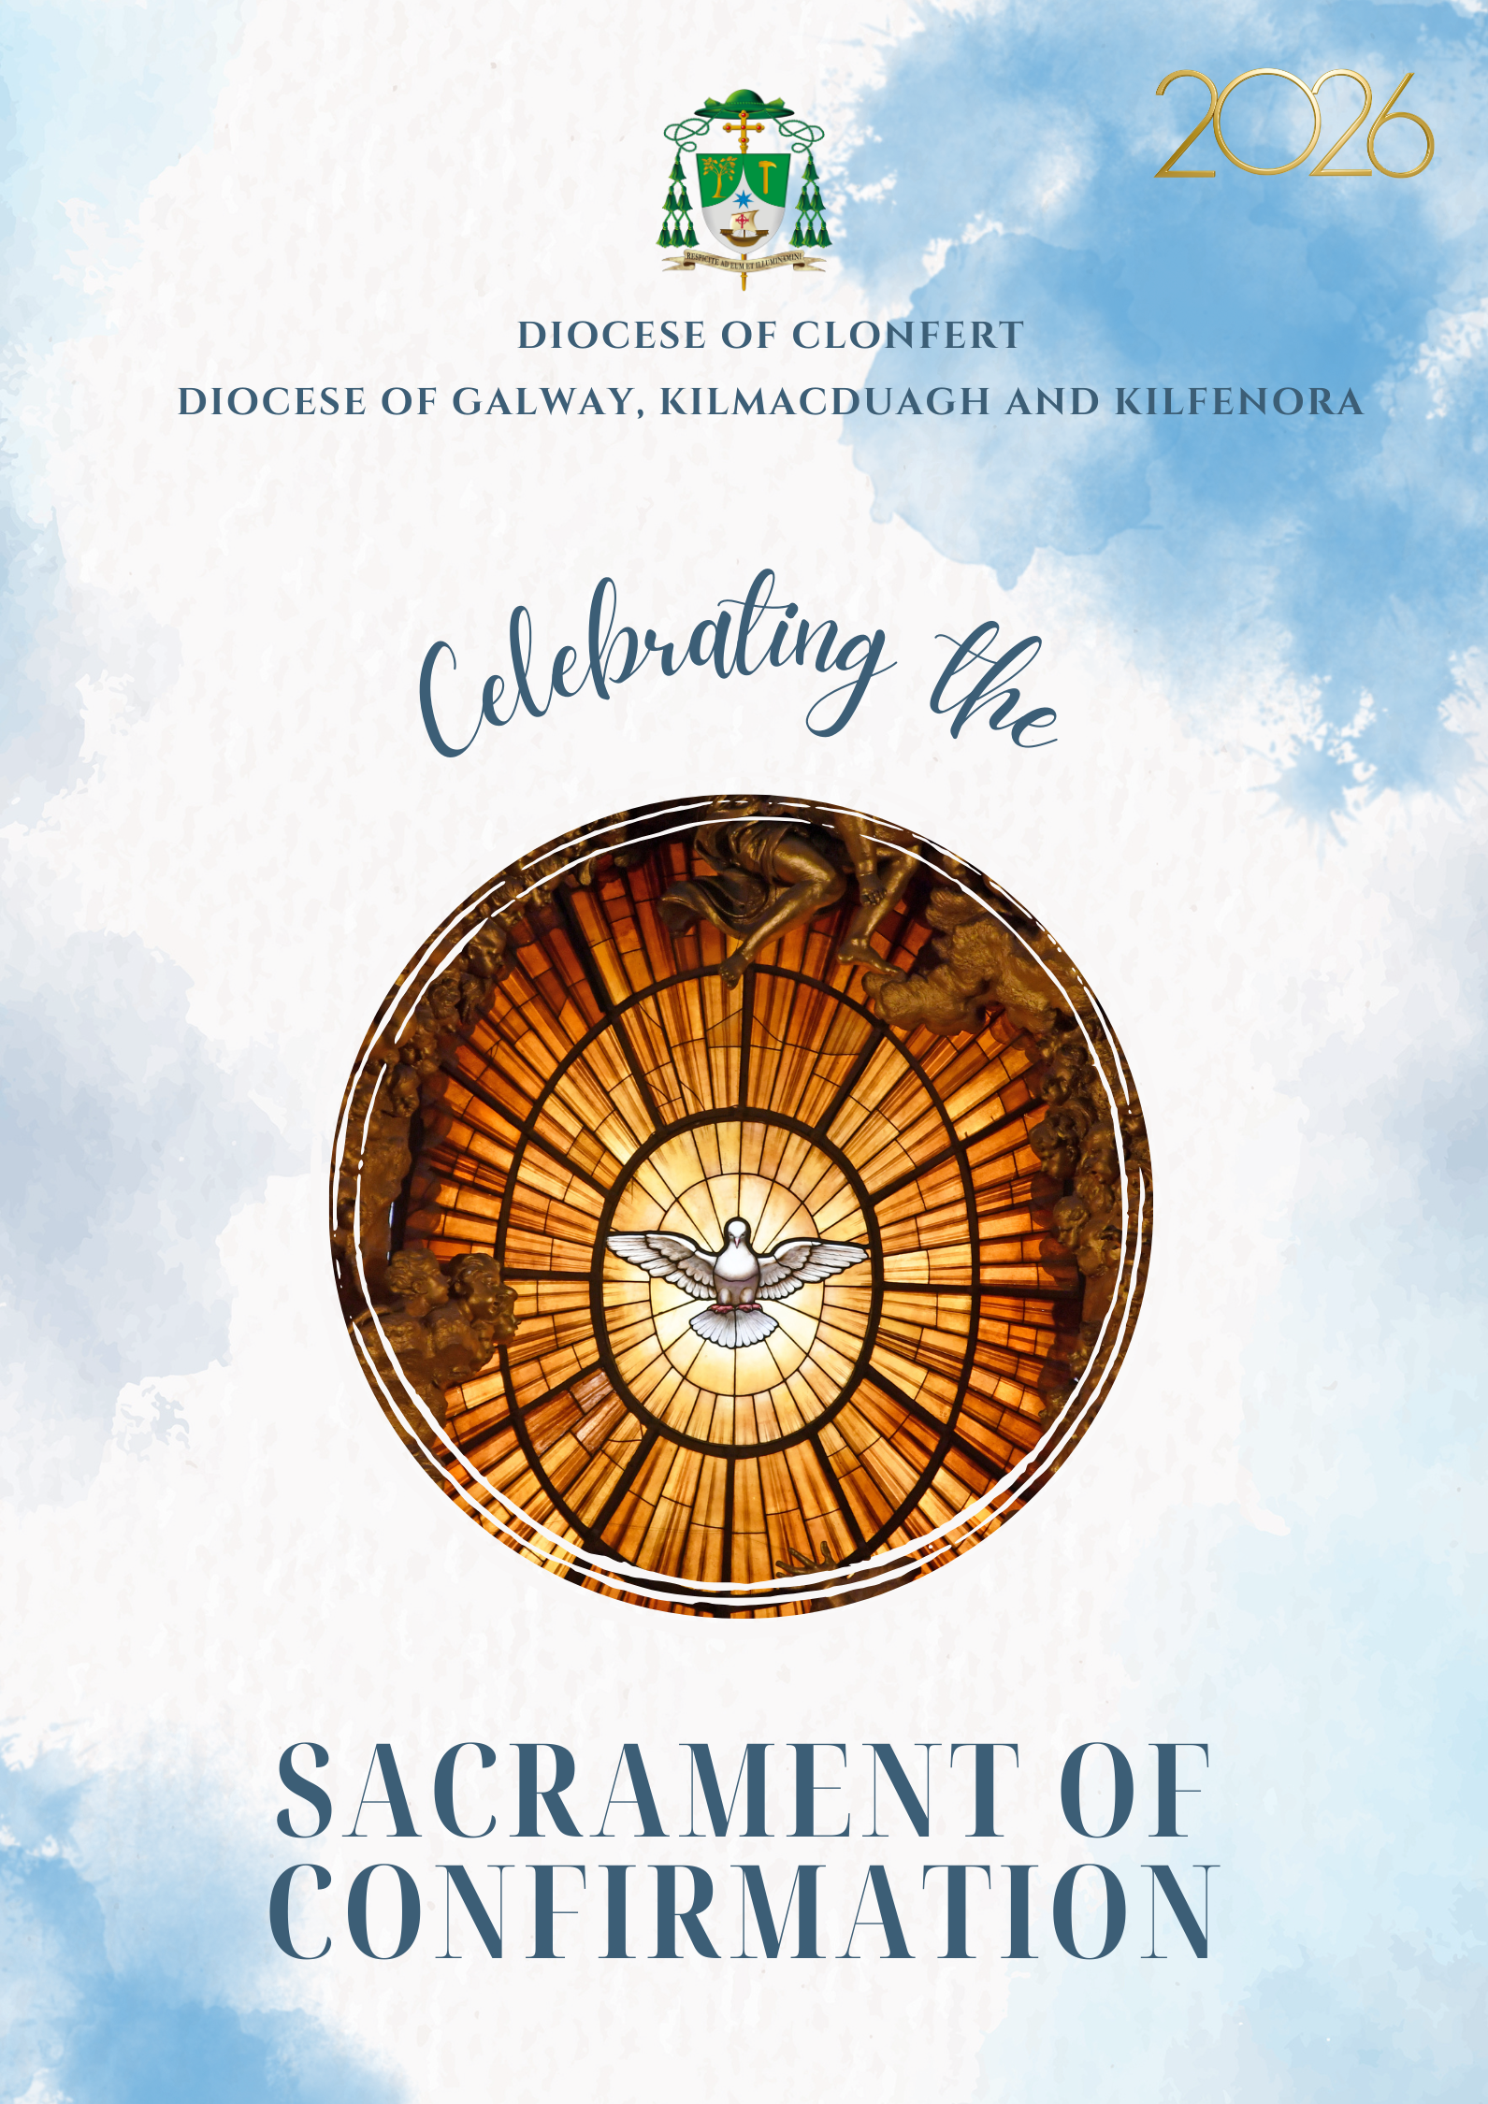

Confirmation is the Sacrament by which the baptised receive a special outpouring of the Holy Spirit. Through ancient rituals and words, God sends his Holy Spirit to give us the strength needed to put into practice the message of Jesus in every aspect of our lives. Christians have held that when the Holy Spirit comes, God gives us the gifts of
- being wise
- increased knowledge especially of spiritual things
- the ability to judge between right and wrong
- understanding how and why things might be as they are
- courage to live life well
- holiness to become more what God intends us to be
- respect for God
These gifts result in the fruits of the Holy Spirit. We become:
- more loving
- more joyful
- more at peace
- more patient
- kinder
- better
- faithful
- gentle
- and contented people
Each person's ability to embrace these affects depends on his or her openness to the sacrament and willingness to accept it as God's personal gift.



INTRODUCTORY RITES

Entrance Hymn (all stand)

The Celebrant and ministers will enter the sanctuary from the sacristy in procession and make their way to their places. The ceremony then begins as follows.

Gathering in God’s Presence (all remain standing)

Candidate: Let us pause in silence for a moment to become aware that God is here with us (Pause)

Candidate: Father – Lord of heaven and earth! Lord of all! We turn to you in prayer.

All: Glory be to the Father. Amen

Candidate: Jesus – God with us. You came to show us God’s love and to teach us how to love one another! We turn to you in prayer!

All: Glory be to the Son. Amen

Candidate: Spirit of God – powerfully present with gifts for your people! Our helper and our guide on life’s journey! We turn to you in prayer!

All: Glory be to the Holy Spirit. Amen

The Parish Priest lights three candles that have been placed in the centre of the altar while all present say:

All: Glory be to the Father, and to the Son and to the Holy Spirit, as it was in the beginning, is now and ever shall be. Amen

Greeting

Celebrant: The grace of our Lord Jesus Christ, and the love of God,
and the communion of the Holy Spirit be with you all.
All: And with your spirit.

Words of Welcome (all sit)

Making Peace with God and with Another

Celebrant: Let us pause for a moment to make peace with God and one another.

After a brief silence, all pray:

Celebrant: For the times when we have not made time for God in our lives. (Pause)

All: We are sorry.

Celebrant: For the times when we have spoken words of hate rather than words of love. (Pause)

All: We are sorry.

Celebrant: For the times when we have done things that were not good. (Pause)

All: We are sorry.

Celebrant: For the times when we were not the best that we could be. (Pause)

All: We are sorry.

Celebrant: May almighty God have mercy on us, forgive us our sins,
And bring us to everlasting life.

All: Amen

Praising God as we Gather (sung)

Glory to God in the highest,
and on earth peace to people of good
will.

We praise you,
we bless you,
we adore you,
we glorify you,
we give you thanks for your great glory,
Lord God, heavenly King,
O God, almighty Father.

Lord Jesus Christ, Only Begotten Son,
Lord God, Lamb of God, Son of the
Father, you take away the sins of the world,
have mercy on us;
you take away the sins of the world,
receive our prayer;
you are seated at the right hand of
the Father, have mercy on us.

For you alone are the Holy One,
you alone are the Lord,
you alone are the Most High,
Jesus Christ,
with the Holy Spirit,
in the glory of God the Father. Amen

Opening Prayer (all stand)

Celebrant: Lord fulfil your promise.
Send your Holy Spirit to make us witnesses before the world
to the good news proclaimed by Jesus Christ, our Lord ,
who lives and reigns with you and the Holy Spirit,
God for ever and ever.

All: Amen.

Invitation to Listen to God’s Word (all sit)

The bishop will now invite all to sit and listen to some readings from the bible

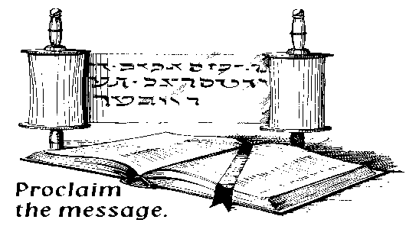
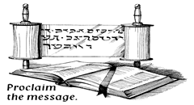
THE LITURGY OF THE WORD

First Reading Acts 2: 1-13

A Reading from the Acts of the Apostles

When Pentecost day came round, they had all met together, when suddenly there came from heaven a sound as of a violent wind which filled the entire house in which they were sitting; and there appeared to them tongues as of fire; these separated and came to rest on the head of each of them. They were all filled with the Holy Spirit and began to speak different languages as the Spirit gave them power to express themselves. Now there were devout men living in Jerusalem from every nation under heaven, and at this sound they all assembled, and each one was bewildered to hear these men speaking his own language. They were amazed and astonished. 'Surely,' they said, 'all these men speaking are Galileans? How does it happen that each of us hears them in his own native language?

The word of the Lord All: Thanks be to God

Responsorial Psalm (sung)

R. Send forth your Spirit O Lord
And renew the face of the earth.

Bless the Lord, my soul!
Lord God, how great you are,
clothed in majesty and glory,
wrapped in light as in a robe. R/.

You make springs gush forth in the valleys,
They flow in between the hills.
On their bank dwell the birds of heaven,
From the branches they sing their song. R/.

How many are your works O Lord
In wisdom you have made them all.
The earth is full of your riches,
Bless the Lord, my soul. R/.

Second Reading: Gal 5: 22-25

A Reading from St Paul to the Galatians

The fruit of the Spirit is love, joy, peace, patience, kindness, goodness, faithfulness, gentleness and self-control. Against such things there is no law. Those who belong to Christ Jesus have crucified the flesh with its passions and desires. If we live by the Spirit, let us also walk by the Spirit.

The word of the Lord All: Thanks be to God

Gospel Acclamation (all stand)

Alleluia, Alleluia, (sung)
Come Holy Spirit and fill the hearts of your faithful
and enkindle in them the Fire of Your love.
Alleluia!

Gospel Mark 1:9-11

Parish Priest: The Lord be with you
All: And with your Spirit

Parish Priest: A Reading from the holy Gospel according to Mark

All: Glory to you Lord

It was at this time that Jesus came from Nazareth in Galilee and was baptised in the Jordan by John. And at once, as he was coming up out of the water, he saw the heavens torn apart and the Spirit, like a dove, descending on him. And a voice came from heaven, 'You are my Son, the Beloved; my favour rests on you.'

The Gospel of the Lord. All: Praise to you Lord Jesus Christ.

Homily (all sit)

RITE OF CONFIRMATION

Invocation of the Holy Spirit

A short hymn invoking the Holy Spirit is now sung

Calling of Candidates

At baptism – parents and sponsors spoke for the candidates. Today they affirm their own willingness to live as part of the Christian family

Parish Priest: This is a special day in our parish. These young people have been preparing for some time now to be confirmed in the Christian Faith. They are to receive the Holy Spirit and to be strengthened to live the Christian life of love of God and others to the full. I now call the following by name and invite them to publicly make this commitment before God and his church gathered here.

After each candidate’s name is called – they and their sponsor stand

Candidate’s Response: Present

Remembering the Day of Baptism

Pouring of Water

Water is poured by the Celebrant from a jug into a bowl to remind us of the waters of baptism

Handing on of the Baptismal Candle

Tapers are lit from the Paschal Candle that symbolises Christ’s presence among us on the journey of life. The candidates Baptismal Candles, held by their sponsors are then lit. When requested the sponsors will had the Candle to the candidate.

Renewal of Baptismal Promises

Celebrant: Do you reject Satan and all his empty promises?

Candidates: I do.

Celebrant: Do you believe in God the Father almighty, creator of heaven and earth?

Candidates: I do.

Celebrant: Do you believe in Jesus Christ, his only Son, our Lord, who was born of the Virgin Mary, was crucified, died, and was buried, rose from the dead, and is now seated at the right hand of the Father?

Candidates: I do.

Celebrant: Do you believe in the Holy Spirit, the Lord, the giver of life, who came upon the apostles at Pentecost and today is given to you sacramentally in Confirmation?

Candidates: I do.

Celebrant: Do you believe in the holy Catholic Church,
the communion of saints, the forgiveness of sins,
the resurrection of the body, and life everlasting?

Candidates: I do.

The Celebrant confirms their profession of faith by proclaiming the faith of the Church:

Celebrant: This is our faith. This is the faith of the Church.
We are proud to profess it in Christ Jesus our Lord.

All: Amen

The Laying on of Hands

Celebrant: My dear friends:
in Baptism God our Father gave the new birth of eternal life to his chosen sons and daughters.
Let us pray to our Father
that he will pour out the Holy Spirit
to strengthen his sons and daughters with his gifts and anoint them to be more like Christ the Son of God.

All pray in silence for a short time. The Celebrant now extends his hands over the candidates and prays that God will send this Holy Spirit upon them to be their helper and their guide. With hands outstretched, the Celebrant sings or says:

Celebrant: All-powerful God,
Father of our Lord Jesus Christ,
by water and the Holy Spirit
you freed your sons and daughters from sin
and gave them new life.
Send your Holy Spirit upon them
to be their Helper and Guide.
Give them the spirit of wisdom and understanding,
the spirit of right judgment and courage,
the spirit of knowledge and reverence.
Fill them with the spirit of wonder and awe in your presence.
We ask this through Christ our Lord. All: Amen

The Anointing with chrism

This is a sacred time – please REMAIN SILENT throughout. During the anointing, a suitable hymn should be sung. Having sanitised their hands and put on face coverings, the Celebrant and Parish Priest/Teacher (carrying the chrism) go to where the candidates are seated. Each candidate holds their confirmation card so that their name can be clearly read. This is a sacred moment - photography or video recording is NOT PERMITTED at this time. The celebrant dips his thumb in the chrism and makes the sign of cross on the forehead of the one to be
confirmed, as he says:

Celebrant: N., be sealed with the Gift of the Holy Spirit

Candidate: Amen

Celebrant: Peace be with you

Candidate: And with your spirit

The candidate and their sponsor should extinguish their candle and be seated

Invitation to attend the Sunday Eucharist

Celebrant: The fullness of Baptism and Confirmation reaches its highpoint when we partake in the Sunday Eucharist with the Christian community. Today we will not be celebrating Mass so I now formally invite the candidates, their parents, families and sponsors to attend Mass in their local Church this weekend where there will be a special welcome for you and I now invite you to commit to doing so.

Celebrant: Will you join the Christian Community at Mass this weekend?

Candidates/Families/Sponsors: We will

Prayers for Our Needs (all stand)

Celebrant: My dear friends: let us be one in prayer to God our Father as we are one in the faith, hope, and love his Spirit gives.

- We pray for those who have been baptised, confirmed and who each week gather around the table of the Lord for Mass – that our lives, the way we live may be an example to all those who do not believe. (Pause)

Lord hear us Lord graciously hear us

- We pray for those who have been confirmed this day – Lord may they always hold open in their lives a space for you and with the power of the Holy Spirit become the best that they can be. (Pause)

Lord hear us Lord graciously hear us

- We pray this day for those who have helped and continue to help those who have been confirmed on the journey of life – parents, grandparents, godparents and sponsors. We pray for our teachers and our priests. (Pause)

Lord hear us Lord graciously hear us

- We pray for those who are sick or suffering, those who are in need of any kind – that the Lord may help and console them. (Pause)

Lord hear us Lord graciously hear us

- We pray for our anxious world at this time – Lord grant us the gift of peace, justice and harmony for all peoples. (Pause)

Lord hear us Lord graciously hear us
- For our own private intentions, we pause in silence (Pause for a while) let us pray to the Lord.

Lord hear us Lord graciously hear us

- For our dead, those we have known and loved in this world and for all the dead, that the Lord may gather them all more closely into his eternal loving embrace. (Pause)

Lord hear us Lord graciously hear us

Celebrant: We gather these and all our prayers, spoken and unspoken, as we pray:

All: Ar n-Athair atá ar neamh, go naofar d'ainm,
go dtagfadh do ríocht, go ndéantar do thoil ar an talamh mar a dhéantar ar neamh. Ár n-arán laethúil tabhair dúinn inniu, agus maith dúinn ár bhfiacha mar a mhaithimidne dar bhféichiúna fein Ach ná lig sinn i gcathú, ach saor sinn ó olc. Amen
Celebrant: Deliver us, Lord, we pray, from every evil,
graciously grant peace in our days,
that, by the help of your mercy,
we may be always free from sin
and safe from all distress,
as we await the blessed hope
and the coming of our Saviour, Jesus Christ.
All: For the kingdom, the power and the glory are yours
now and for ever

Moment of Reflection - Peace Prayer of St Francis of Assisi (all sit)

(Instrumental music in background)

Lord, make me an instrument of your peace:
where there is hatred, let me sow love;
where there is injury, pardon;
where there is doubt, faith;
where there is despair, hope;
where there is darkness, light;
where there is sadness, joy.

O divine Master, grant that I may not so much seek
to be consoled as to console,
to be understood as to understand,
to be loved as to love.
For it is in giving that we receive,
it is in pardoning that we are pardoned,
and it is in dying that we are born to eternal life. Amen.

Word of congratulations and thanks from our Parish Priest

Concluding words

Blessing (all stand)

Celebrant: Bow your heads and pray for God’s blessing

May God the Father almighty bless you,
whom he has made his adopted sons and daughters
reborn from water and the Holy Spirit,
and may he keep you worthy of his fatherly love.
All: Amen

May his Only Begotten Son,
who promised that the Spirit of truth would abide in his Church,
bless you and confirm you by his power
in the confession of the true faith.
All: Amen

May the Holy Spirit,
who kindles the fire of charity in the hearts of disciples,
bless you and lead you blameless and gathered as one
into the joy of the Kingdom of God.
All: Amen

And may almighty God bless all of you, who are gathered here,
the Father, and the Son, and the Holy Spirit,
come down on you and remain with you for ever.
All: Amen

Sending Out

Celebrant: Empowered by the Spirit, we now, like the Apostles on that First Pentecost Day, are sent out into our world to proclaim the Good News: God loves us and he has set our hearts on fire with love for him and for each other.

One of those confirmed prays:

Empowered by the Spirit, I go into the world
Empowered by the Spirit, I go to my neighbours
Empowered by the Spirit, I am sent to my friends
Empowered by the Spirit, I go to my school
Empowered by the Spirit, I am sent to my family
Empowered by the Spirit, we move out now

All those confirmed say together with the congregation:

Filled with the Holy Spirit, we move out now. Out into our world to proclaim in word and deed the wonderful things God does for us. Amen.

Recessional Hymn

