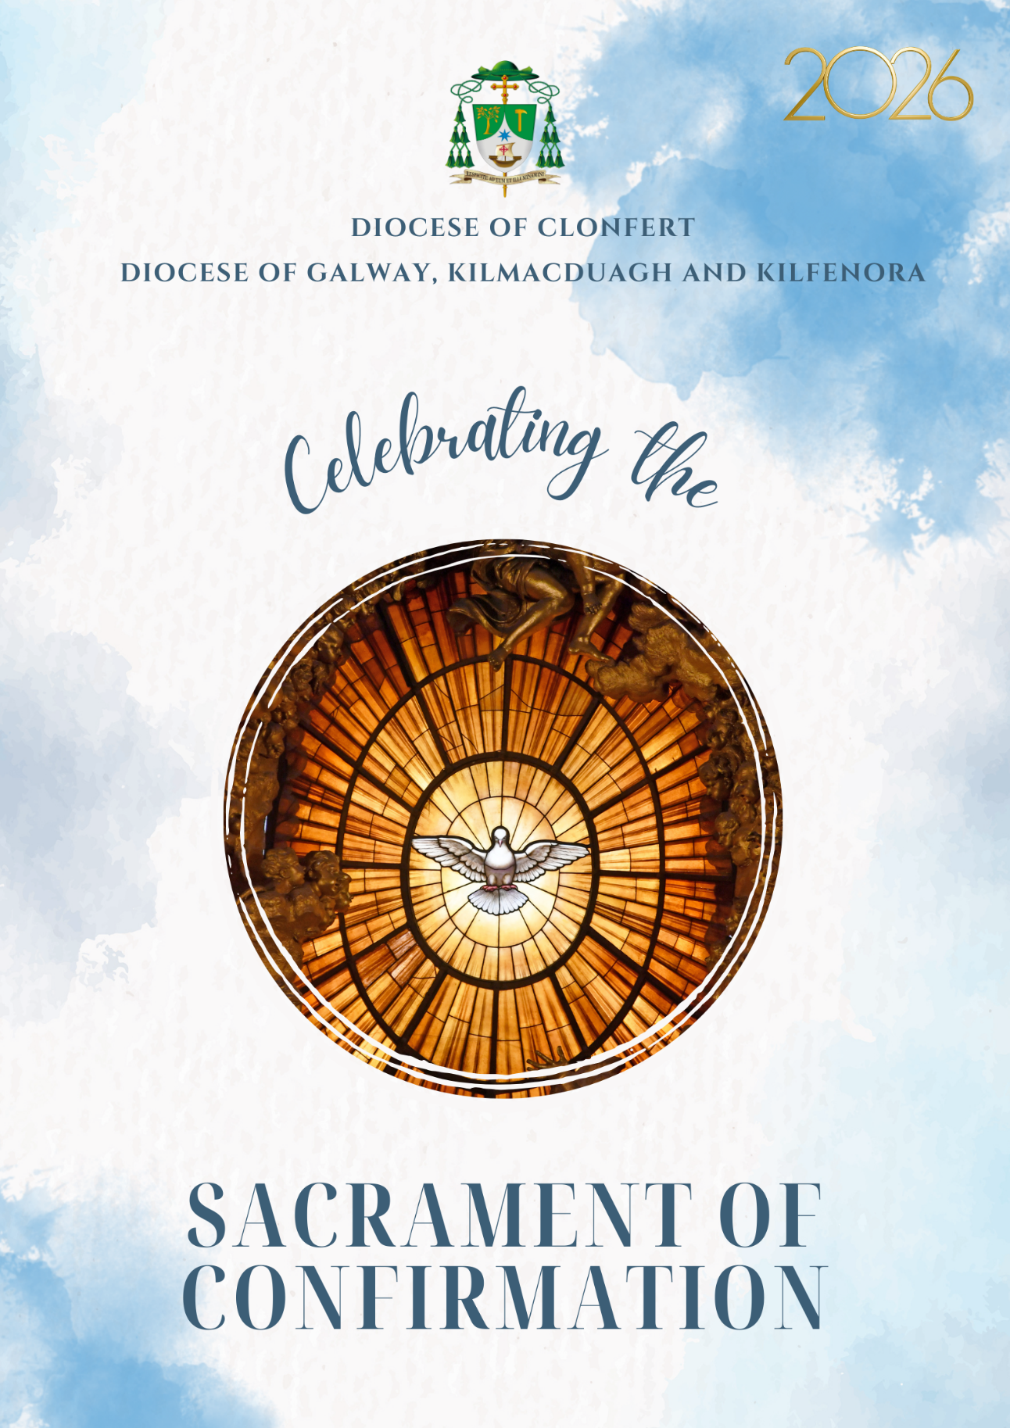

Confirmation is the Sacrament by which the baptised receive a special outpouring of the Holy Spirit. Through ancient rituals and words, God sends his Holy Spirit to give us the strength needed to put into practice the message of Jesus in every aspect of our lives. Christians have held that when the Holy Spirit comes, God gives us the gifts of:
• being wise,
• increased knowledge, especially of spiritual things,
• the ability to judge between right and wrong,
• understanding how and why things might be as they are,
• courage to live life well,
• holiness to become more what God intends us to be,
• respect for God.

These gifts result in the fruits of the Holy Spirit. We become:
• more loving,
• more joyful,
• more at peace,
• more patient,
• kinder,
• better,
• faithful,
• gentle,
• and contented people.

Each person’s ability to embrace these affects depends on his or her openness to the sacrament and willingness to accept it as God’s personal gift.


Immediately before the ceremony begins, the parish priest or his representative will welcome the people and brief them on the ceremony.

— Introductory Rite —

Celebrant: In the name of the Father, and of the Son,
and of the Holy Spirit.
All: Amen.
Celebrant: The grace of our Lord Jesus Christ,
and the love of God,
and the communion of the Holy Spirit
be with you all.
All: And with your spirit.

Penitential Act
Celebrant: My brothers and sisters,
to prepare ourselves to celebrate the sacred mysteries,
let us acknowledge our sins.

All: I confess to almighty God
and to you, my brothers and sisters,
that I have greatly sinned,
in my thoughts and in my words,
in what I have done and in what I have failed to do,
through my fault, through my fault,
through my most grievous fault;
therefore I ask blessed Mary ever-Virgin,
all the Angels and Saints,
and you, my brothers and sisters,
to pray for me to the Lord our God.

Celebrant: May almighty God Have mercy on us, forgive us our sins, and lead us into everlasting life.
All: Amen.

Celebrant: Lord, have mercy. All: Lord, have mercy.
Celebrant: Christ, have mercy. All: Christ, have mercy.
Celebrant: Lord, have mercy. All: Lord, have mercy.

Gloria
All: Glory to God in the highest,
and on earth peace to people of good will.
We praise you,
we bless you,
we adore you,
we glorify you,
we give you thanks for your great glory,
Lord God, heavenly King,
O God, almighty Father.
Lord Jesus Christ, Only Begotten Son,
Lord God, Lamb of God, Son of the Father,
you take away the sins of the world,
have mercy on us;
you take away the sins of the world,
receive our prayer;
you are seated at the right hand of the Father,
have mercy on us.
For you alone are the Holy One,
you alone are the Lord,
you alone are the Most High,
Jesus Christ,
with the Holy Spirit,
in the glory of God the Father.
Amen.

Opening Prayer
Celebrant: Grant, we pray, almighty and merciful God,
that the Holy Spirit, coming near
and dwelling graciously within us,
may make of us a perfect temple of his glory.
Through our Lord Jesus Christ, your Son,
who lives and reigns with you in the unity
of the Holy Spirit, one God, for ever and ever. All: Amen.
— Liturgy of the Word —

First Reading
A reading from the Acts of the Apostles Acts 2: 1–6
When Pentecost day came round, they had all met together, when suddenly there came from heaven a sound as of a violent wind which filled the entire house in which they were sitting; and there appeared to them tongues as of fire; these separated and came to rest on the head of each of them. They were all filled with the Holy Spirit and began to speak different languages as the Spirit gave them power to express themselves. Now there were devout men living in Jerusalem from every nation under heaven, and at this sound they all assembled, and each one was bewildered to hear these men speaking his own language. They were amazed and astonished.
The word of the Lord.
All: Thanks be to God.

Responsorial Psalm (sung)
R: Send forth your Spirit, O Lord,
and renew the face of the earth.

1. Bless the Lord, my soul!
Lord God, how great you are,
clothed in majesty and glory!
wrapped in light as in a robe. R.

2. You make springs gush forth in the valleys,
They flow in between the hills.
On their bank dwell the birds of heaven,
from the branches they sing their song. R.

3. How many are your works, O Lord,
in wisdom you have made them all.
The earth is full of your riches,
bless the Lord, my soul. R.

Second Reading
A reading from St Paul to the Galatians Gal 5: 22–25
The fruit of the Spirit is love, joy, peace, patience, kindness, goodness, faithfulness, gentleness, and self-control. Against such things there is no law. Those who belong to Christ Jesus have crucified the flesh with its passions and desires. If we live by the Spirit, let us also walk by the Spirit.
The Word of the Lord.
All: Thanks be to God.

All stand.

Gospel Acclamation
Alleluia, alleluia!
Come Holy Spirit,
fill the hearts of your faithful,
and kindle in them the fire of your love.
Alleluia!

The Gospel
A reading from the holy Gospel according to Mark Mk 1:9–11
Jesus came from Nazareth in Galilee and was baptised in the Jordan by John. No sooner had he come up out of the water than he saw the heavens torn apart and the Spirit, like a dove, descending on him. And a voice came from heaven, ‘You are my Son, the Beloved; my favour rests on you’.
The Gospel of the Lord.
All: Praise to you, Lord Jesus Christ.

All sit during the homily.

This or another appropriate hymn invoking the Holy Spirit may be sung.
Come Holy Ghost, Creator come,
Descend from heaven’s throne,
Come take possession of our hearts,
And make them all your own.

Then come great Spirit to your own,
Our hearts make pure and strong,
Direct our weary steps today,
And turn our wills from wrong.

All glory to the Father be,
With his eternal son,
The same unto the Paraclete,
While endless ages run.

— Renewal of Baptismal Promises —

After the homily the Celebrant questions the candidates:
Celebrant: Do you reject Satan and all his works and all his empty promises?

The candidates respond together:
Candidates: I do.

Celebrant: Do you believe in God the Father almighty, creator of heaven and earth?
Candidates: I do.
Celebrant: Do you believe in Jesus Christ, his only Son, our Lord, who was born of the Virgin Mary, was crucified, died, and was buried, rose from the dead, and is now seated at the right hand of the Father?
Candidates: I do.

Celebrant: Do you believe in the Holy Spirit, the Lord, the giver of life, who came upon the apostles at Pentecost and today is given to you in the sacrament of Confirmation?
Candidates: I do.
Celebrant: Do you believe in the holy catholic Church, the communion of saints, the forgiveness of sin, the resurrection of the body and life everlasting?
Candidates: I do.

Celebrant: This is our faith. This is the faith of the Church. We are proud to profess it in Christ Jesus our Lord.
All reply: Amen.

— Laying on of Hands —

Then the Celebrant (together with the priests assisting him) stands with joined hands, facing the people, and says:
My dear friends:
In baptism God our Father gave the new birth of eternal life
to his chosen sons and daughters.
Let us pray to our Father
that he will pour out the Holy Spirit
to strengthen his sons and daughters with his gifts
and anoint them to be more like Christ, the Son of God.

All pray in silence for a short time. The Celebrant now extends his hands over the candidates and prays that God will send this Holy Spirit upon them to be their helper and their guide. With hands outstretched, the Celebrant sings or says:

All powerful God, Father of our Lord Jesus Christ,
by water and the Holy Spirit
you freed your sons and daughters from sin
and gave them new life.
Send your Holy Spirit upon them
to be their helper and guide.
Give them the spirit of wisdom and understanding,
the spirit of right judgement and courage,
the spirit of knowledge and reverence.
Fill them with the spirit of wonder and awe in your presence.
We ask this through Christ our Lord.
All: Amen.

— Anointing with Chrism —

This is a most sacred time – please remain silent throughout. During the anointing, suitable hymns should be sung. The Celebrant and parish priest/teacher go to where the candidates are assembled. The priest or teacher tells the celebrant the first Christian name and the confirmation name of the candidate to be confirmed. This is a sacred moment: photography or videorecording is not permitted at this time.The Celebrant dips his thumb in the chrism and makes the sign of cross on the forehead of the one to be confirmed, as he says:

Celebrant: N……., be sealed with the Gift of the Holy Spirit.
Candidate: Amen.
Celebrant: Peace be with you.
Candidate: And with your Spirit.

— Prayer of the Faithful —

Celebrant: My dear friends, let us be one in prayer to God our Father as we are one in the faith, hope, and love his Spirit gives.

1. We pray for those who have been baptised, confirmed and who each week gather around the table of the Lord for Mass – that our lives, the way we live may be an example to all those who do not believe. (Pause.)
Lord, hear us.
Lord, graciously hear us.
2. We pray for those who have been confirmed this day – Lord may they always hold open in their lives a space for you and with the power of the Holy Spirit become the best that they can be. (Pause.)
Lord, hear us.
Lord, graciously hear us.

3. We pray this day for those who have helped and continue to help those who have been confirmed on the journey of life – parents, grandparents, godparents and sponsors. We pray for our teachers and our priests. (Pause.)
Lord, hear us.
Lord, graciously hear us.

4. We pray for those who are sick or suffering, those who are in need of any kind – that the Lord may help and console them. (Pause.)
Lord, hear us.
Lord, graciously hear us.

5. We pray for our anxious world at this time – Lord grant us the gift of peace, justice and harmony for all peoples. (Pause.)
Lord, hear us.
Lord, graciously hear us.

6. For our own private intentions, we pause in silence. (Pause for a while.)
Let us pray to the Lord.
Lord, hear us.
Lord, graciously hear us.

7. For our dead, those we have known and loved in this world and for all the dead, that the Lord may gather them all more closely into his eternal loving embrace. (Pause.)
Lord, hear us.
Lord, graciously hear us.

Celebrant: Heavenly Father, we bring before you these our prayers and ask that you hear and answer them, for we make them in faith and love through Christ our Lord.
All: Amen.

— The Liturgy of the Eucharist —

Offertory Procession
The gifts of bread and wine are brought forth from the congregation at this time.

Celebrant: Receive in your mercy, O Lord,
the prayers of your servants
and grant that, being conformed more perfectly to your Son,
they may grow steadily in bearing witness to him,
as they share in the memorial of his redemption,
by which he gained for us your Holy Spirit.
Through Christ our Lord.
All: Amen.

Eucharistic Prayer II
The Celebrant, with hands extended says:
Celebrant: The Lord be with you.
All: And with your spirit.
Celebrant: Lift up your hearts.
All: We lift them up to the Lord.
Celebrant: Let us give thanks to the Lord our God.
All: It is right and just.

Celebrant: It is truly right and just, our duty and our salvation,
always and everywhere to give you thanks,
Lord, holy Father, almighty and eternal God,
through Christ our Lord.
Ascending above all the heavens
and sitting at your right hand,
he poured out the promised Holy Spirit
on your adopted children.
Therefore, now and for ages unending,
with all the host of Angels,
we sing to you with all our hearts,
crying out as we acclaim:

All: Holy, holy, holy Lord God of hosts.
Heaven and earth are full of your glory.
Hosanna in the highest.
Blessed is he who comes in the name of the Lord.
Hosanna in the highest.

Celebrant: You are indeed Holy, O Lord,
the fount of all holiness.
Make holy, therefore, these gifts, we pray,
by sending down your Spirit upon them like the dewfall,
so that they may become for us
the Body and  Blood of our Lord Jesus Christ.

At the time he was betrayed
and entered willingly into his Passion,
he took bread and, giving thanks, broke it,
and gave it to his disciples, saying:
TAKE THIS, ALL OF YOU, AND EAT OF IT,
FOR THIS IS MY BODY,
WHICH WILL BE GIVEN UP FOR YOU.
In a similar way, when supper was ended,
he took the chalice
and, once more giving thanks,
he gave it to his disciples, saying:
TAKE THIS, ALL OF YOU, AND DRINK FROM IT,
FOR THIS IS THE CHALICE OF MY BLOOD,
THE BLOOD OF THE NEW AND ETERNAL COVENANT,
WHICH WILL BE POURED OUT FOR YOU AND FOR MANY,
FOR THE FORGIVENESS OF SINS.
DO THIS IN MEMORY OF ME.

Celebrant: The mystery of faith.
All: We proclaim your death, O Lord, and profess your
Resurrection until you come again.

Celebrant: Therefore, as we celebrate
the memorial of his Death and Resurrection,
we offer you, Lord,
the Bread of Life and the Chalice of salvation,
giving thanks that you have held us worthy
to be in your presence and minister to you.
Humbly we pray
that, partaking of the body and Blood of Christ,
we may be gathered into one by the Holy Spirit.
Remember, Lord, your Church,
Spread throughout the world,
and bring her to the fullness of charity,
together with Francis our Pope, and Michael our Bishop,
and all the clergy.
Remember also, Lord, your servants
whom you have been pleased to confirm today
by bestowing the Holy Spirit
and keep them in your grace.

Remember also our brothers and sisters
who have fallen asleep in the hope of the resurrection,
and all who have died in your mercy:
welcome them into the light of your face.
Have mercy on us all, we pray,
that with the Blessed Virgin Mary, Mother of God,
with blessed Joseph, her spouse,
with the blessed Apostles,
and all the Saints who have pleased you throughout the ages,
that we may merit to be coheirs to eternal life,
and may praise and glorify you
through your Son, Jesus Christ.
Through him, and with him, and in him,
O God, almighty Father,
in the unity of the Holy Spirit,
all glory and honour is yours,
forever and ever.
All: Amen.

— Communion Rite / Deasgnátha na Comaoineach —

Ceiliúraí: Aitheanta an tslánaithe dár dtreorú
agus briathar Dé dár dteagasc,
tá sé de mhisneach againn a rá.
Pobal: Ár nAthair atá ar neamh,
go naofar d’ainm, go dtaga do ríocht,
go ndéantar do thoil ar an talamh,
mar a dhéantar ar neamh.
Ár n-arán laethúil tabhair dúinn inniu,
agus maith dúinn ár bhfiacha,
mar a mhaithimidne dár bhféichiúna féin,
agus ná lig sinn i gcathú, ach saor sinn ó olc.

Ceiliúraí: Saor sinn ó gach olc, impímid ort, a Thiarna.
Tabhair dúinn go cineálta síocháin lenár linn,
ionas go mbeimid,le cúnamh do thrócaire,
saor ón bpeaca i gcónai
agus slán ón uile bhuairt
agus sinn ag súil leis an dóchas naofa
agus le teacht ár Slánaitheora, Íosa Críost.
Pobal: Óir is leatsa an ríocht agus an chumhacht agus an ghlóir trí shaol na saol.

Celebrant: Lord Jesus Christ,
who said to your Apostles:
Peace I leave you, my peace I give you,
look not on our sins,
but on the faith of your Church,
and graciously grant her peace and unity
in accordance with your will.
Who live and reign for ever and ever.
All: Amen.

Celebrant: The peace of the Lord be with you always.
All: And with your spirit.

All: Lamb of God, you take away the sins of the world:
have mercy on us.
Lamb of God, you take away the sins of the world:
have mercy on us.
Lamb of God, you take away the sins of the world:
grant us peace.

All kneel.

Celebrant: Behold the Lamb of God,
behold him who takes away the sins of the world.
Blessed are those called to the supper of the Lamb.

All: Lord, I am not worthy
that you should enter under my roof,
but only say the word
and my soul shall be healed.

Receiving Communion
The reception of communion is a very sacred moment – please note the following.
This is a sacred time. Please refrain from talking.
Join in the communion hymns or maintain a respectful silence.
No photography or video recording.
Non-Catholics or Catholics who feel they are not sufficiently prepared to receive communion at this time may come forward for a blessing. Please indicate that you wish to receive a blessing by crossing your arms over your chest with the palms turned inwards.
Communion may be received in the hand or on the tongue.
If in the hand:
• As you approach the priest make a small bow.
• Place one hand under the other hand with palms opened and facing upwards.
• The priest will place the host in the palm of your hand.
• Take the hand from underneath and pick up the host and reverently place it on your tongue.
• Make the sign of the cross.
• Return to your seat and spend some time in prayer with the Lord you have received.

If on the tongue:
• As you approach the priest make a small bow.
• Join your hands and put your tongue out.
• The priest will place the host on your tongue.
• Make the sign of the cross.
• Return to your seat and spend some time in prayer with the Lord you have received.

The host must always be consumed during the Mass. It cannot be taken away under any circumstances.

Appropriate hymns may be sung during Communion, such as:

Be still and know that I am God,
be still and know that I am God,
be still and know that I am God.
I am the Lord that healeth thee,
I am the Lord that healeth thee,
I am the Lord that healeth thee.
In thee, O Lord, I put my trust,
in thee, O Lord, I put my trust,
in thee, O Lord, I put my trust.

Christ be with me, Christ within me,
Christ behind me, Christ before me,
Christ beside me, Christ to win me,
Christ to comfort and restore me.
Christ beneath me, Christ above me,
Christ in quiet, Christ in danger,
Christ in hearts of all who love me,
Christ in mouth of friend and stranger.

Post-Communion Reflection (if chosen)

Celebrant: Accompany with your blessing from this day forward, O Lord,
those who have been anointed with the Holy Spirit
and nourished by the Sacrament of your Son,
so that, with all trials overcome,
they may gladden your Church by their holiness
and, through their works and their charity,
foster her growth in the world.
Through Christ our Lord.
All: Amen.

— Concluding Rite —

Celebrant: The Lord be with you.
All: And with your Spirit.

Final Blessing
All stand.

Celebrant: Bow your heads and pray for God’s blessing.
May God the Father almighty bless you,
whom he has made his adopted sons and daughters
reborn from water and the Holy Spirit,
and may he keep you worthy of his fatherly love.
All: Amen.

Celebrant: May his Only Begotten Son,
who promised that the Spirit of truth would abide in his Church,
bless you and confirm you by his power
in the confession of the true faith.
All: Amen.

Celebrant: May the Holy Spirit,
who kindles the fire of charity in the hearts of disciples,
bless you and lead you blameless and gathered as one
into the joy of the Kingdom of God.
All: Amen.

Celebrant: And may Almighty God bless all of you, who are gathered here,
the Father, and  the Son, and  the Holy Spirit,
come down on you and remain with you for ever.
All: Amen.

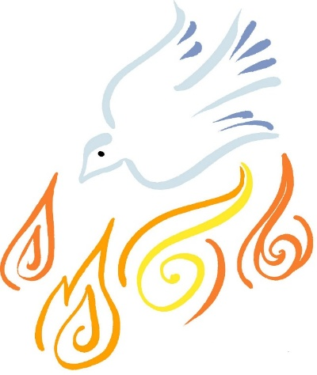

Those who may wish to take the ‘Confirmation Pledge’
please phone the Diocesan Office at 091 563566 or
email info@galwaydiocese.ie for further details.

Our sincere thanks to all who helped out in whatever way with this Confirmation liturgy. We remember in our prayers all those confirmed, their families, sponsors, teachers, priests and friends and wish them all God’s blessings in life.

